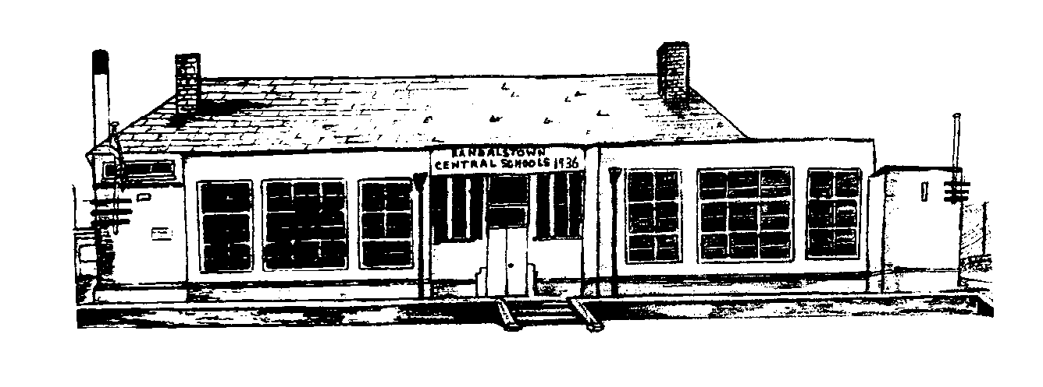

Attendance Policy

Randalstown Central
Primary School

To Be Reviewed
2022
2021
Adopted
October 2021
Attendance Policy Summary:
Randalstown Central Primary School recognises that punctual and regular attendance alongside high standards of behaviour is an essential prerequisite to effective learning and is, therefore, committed to maintaining high levels of attendance, punctuality and positive behaviour. To this end, we in Randalstown Central actively promote a teaching and learning ethos which encourages all pupils to attend whatever their level of ability or need.
In accordance with other school policies, all members of the school community should be able to
thrive, feel respected, safe and secure.

Schools have a legal responsibility to report any pupil whose absence falls below 85% or where there has been an absence of more than 10 days and where it is proved impossible to make contact with a parent or carer.

The School takes an attendance register once a day, and this shows whether the pupil is present, engaged in an approved activity off site, attends late or is absent.

If a pupil is absent, every half-day absence has to be classified by the school as either authorised or unauthorised. Only the school can authorise the absence, not parents/ carers. This is why information about the cause of each absence is required in writing.
Authorised absences are mornings or afternoons away from school for a good reason like illness or other unavoidable cause.
Unauthorised absences are those which the school does not consider reasonable and for which no ‘leave’ has been given. This includes:
- parents/carers keeping pupils off school unnecessarily
- truancy before or during the school day
- absences which have never been properly explained
- children who arrive at school after 9:15 will be considered too late to get a registration mark

It is hoped that parents/carers, school staff and statutory authorities can work closely to overcome any problems which may affect a pupil’s attendance. If a pupil is reluctant to attend, it is never a good idea to cover up their absence or to give in to pressure to excuse them from attending. This will only give the impression that attendance does not matter, and may make matters worse.

Procedures:
Registration:
Morning classes begins at 9:00 a.m. promptly and only pupils who attend on the school bus may arrive after this time. Pupils who are late will be recorded as such in the register.

Absence:
Pupils must bring a written explanation of the absence from his/her parent/carer to the class teacher on their return to school, or notify the school via ParentMail. This notification should include:
- the pupil’s full name and class
- the date(s) of the absence
- as full an explanation as possible for the absence
- the name of the parent / carer in block capitals along with their signature

To assist in this matter a proforma “Absence Note” has been devised (see attached) which can be used (additional copies available from Office). Parents can also inform the school of absences by ParentMail
If a pupil fails to bring a note within two days of returning to school they will be reminded about the importance of bringing it in. Pupils, who persistently fail to bring absence notes, will be brought to the attention of the Principal who will make contact with the home.

Absence for Medical reasons:
Parents/carers are asked, whenever possible, to make appointments outside school hours. If an appointment has to be made during school hours a written explanation must be provided stating clearly the time of the appointment. If there are frequent absences for medical reasons, parents/carers may be asked to provide medical evidence in the form of a doctor’s certificate.
If a pupil has a medical condition that may affect attendance and punctuality parents/carers are asked to contact the school to discuss possible arrangements with their child’s class teacher.

Family Holidays during Term Time:
Randalstown Central Primary School strongly discourages holidays during term time due to the impact that they have on pupils’ learning. Parents/carers must contact the school, prior to booking any holiday to explain the need to remove a pupil from school during term time. The contact should be in the form of a letter addressed to the Principal.
Currently there is no legislation in Northern Ireland with regard to holidays in term time (as there is in the rest of the United Kingdom) However, if a pupil’s attendance falls below 85% in a school year, the school concerned is obliged to contact the Educational Welfare Officer.

Education Welfare
Education Welfare works in partnership with the young people, their families, the schools, other education services as well as statutory and voluntary agencies.

The Law
Young people are educated because the law says there is an entitlement to education for 12 years (7 primary,, 5 secondary). In fac,t most children go to school and enjoy the opportunities school has to offer. However, some young people have attendance or other problems that they need help to overcome. It is a parent’s responsibility to ensure that their children go to school.

The Education Welfare Service (EWS) following assessment can apply for an Education Supervision Orders or Parental Prosecution for parents/carers whose children are not attending school on a regular basis.

If Attendance is poor.
The School will refer a young person to the EWS if their attendance is causing concern. The Education Welfare Officer (EWO) will contact the parent/carer and support them in trying to improve. All EWO’s work in a partnership with Parents/Carers and other support agencies to ensure young people attend school and attain.

The Role of the Education Welfare Officer (EWO)
An Education Welfare Officer:
- will meet with the school to respond to written referrals
- make an assessment of the situation and establish a support plan with the young person, parent and school
- can act on a parent’s request to talk to the young person’s school or other agencies on their behalf.
- can make referrals to other support services e.g. Medical officer or Educational Psychologist.
- can tell families about other specialist support projects in the area e.g. EOTAS, Parent or Pupil Support Groups.

If Attendance does not improve
If there is no improvement the EWO will have to:
- Ask the parent/carer to attend a Family Consultation Meeting
- Convene a School Attendance Panel Meeting
- Convene an Education Planning Meeting, involving Social Services and other agencies. If the situation does not improve then the decision can be made to apply to the court for an Order or prosecute the parent/carer.

The School’s Role in the EWS Process
The school will keep a parent informed if there are concerns about a pupil’s attendance. They will advise a parent/carer when they make a referral to the EWS.
The school will work in partnership with the parent/carer, the Education Welfare Officer and any other agencies involved with a family.

The Welfare of the Child
The Education Welfare Service works under the principles of the Children (NI) Order 1995, Human Rights Act 1998 and has a commitment to the United Nations Convention of the Right of the Child. These Principles include:
- The welfare of the child is the paramount consideration in all matters.
- The child’s voice should be heard and taken into account in all matters relating to the child.
- The child has a right to free and compulsory education.

Summary of Steps in place to deal with less than full attendance

School Secretary will contact parent regarding absence with the intention of encouraging better attendance
Children whose attendance falls below 95%

School Principal will contact parent regarding absence. The Principal will try to put in place a plan with the parent to help improve attendance.
Children whose attendance falls below 90%

The school Principal will contact parent regarding the continuing poor attendance and advise parent that the ‘EWO’ Service would become involved to help improve attendance.

Children whose attendance falls below 85%

Sample copy of absence note

Randalstown Central Primary School
Absence Note

To be given to your child’s class teacher on the day your child returns to school, following any absence:
Pupil Name
Class
Absence Dates | From |  |  | To
Reason
Parent/Carer (Print)
Parent/Carer (Signed)
Date

