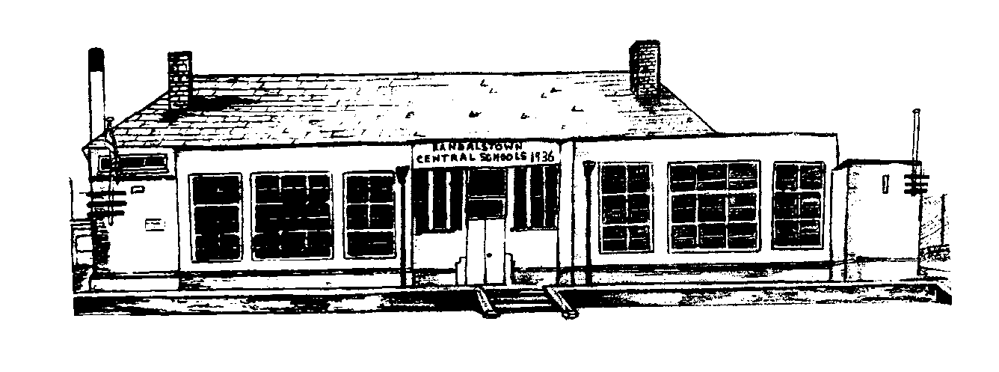

Whistleblowing Policy

Randalstown Central
Primary School
To Be Reviewed
2023
Adopted
February 2022
1. Introduction
1.1 Whistleblowing has been defined as: ‘the disclosure by an employee or professional of confidential information which relates to some danger, fraud or other illegal or unethical conduct connected with the work place, be it of the employee or his/her fellow employees’ (Public Concern at Work Guidelines 1997).
1.2 Statutory protection for employees who whistle-blow in N. Ireland is provided by The Public Interest Disclosure (Northern Ireland) Order 1998,
(see www.legislation.hmso.gov.uk/si/si1998/19981763.htm)
also known as the ‘Whistleblowers Act’. It provides protection for employees who disclose information which, in the reasonable belief of the worker making the disclosure, tends to show conduct or practice within the school which is potentially illegal, corrupt, improper, unsafe or unethical or which amounts to malpractice.
1.3 This policy applies to all school staff including full and part time, casual, temporary, substitute staff and to individuals undertaking work experience in the school.
2. Aims and scope of policy
2.1 The Governors are committed to high standards in all aspects of the school and will treat whistleblowing as a serious matter. In line with the Governors’ commitment to openness, probity and accountability, members of staff are encouraged to report concerns which will be taken seriously, investigated and appropriate action taken in response.
2.2 This policy aims to:
- give confidence to members of staff about raising concerns about conduct or practice which is potentially illegal, corrupt, improper, unsafe or unethical or which amounts to malpractice or is inconsistent with school standards and policies so that she or he is encouraged to act on those concerns
- provide members of staff with avenues to raise concerns
- ensure that members of staff receive a response to the concerns they have raised and feedback on any action taken
- offer assurance that members of staff are protected from reprisals or victimisation for whistleblowing action undertaken in good faith and within the meaning of the Public Interest Disclosure Order.
2.3 This policy covers whistleblowing relating to alleged:
- unlawful conduct
- failure to comply with a statutory or legal obligation
- potential maladministration, misconduct or malpractice
- health and safety issues including risks to the public as well as risks to pupils and members of staff
- action that has caused or is likely to cause danger to the environment
- abuse of authority
- unauthorised use of public or other funds, fraud or corruption
- breaches of financial regulations or policies
- mistreatment of any person
- action that has caused or is likely to cause physical danger to any person or risk serious damage to school property
- sexual, physical or emotional abuse of members of staff or pupils
- unfair discrimination or favouritism
- racist incidents or acts, or racial harassment and
- any attempt to prevent disclosure of any of the issues listed.
2.4. The Public Interest Disclosure Order sets out the full statutory rights and obligations of members of staff wishing to whistle blow.
3. Safeguards against reprisal, harassment and victimisation
3.1 The Governors will not tolerate harassment or victimisation of members of staff when matters are raised in accordance with the Public Interest Disclosure Order provisions. Any member of staff who victimises or harasses a member of staff as a result of their having raised a concern in accordance with the whistleblowing policy will be dealt with under the Governors’ staff disciplinary procedures.
4. Confidentiality
4.1 The Governors recognise that members of staff may want to raise concerns in confidence and will do its utmost to protect the identity of members of staff who raise a concern and do not want their name disclosed.
4.2 However, investigation into the concern could reveal the source of the information; statements may be required from the member of staff as part of the evidence gathering, which could be seen by all parties involved. If the investigation leads to prosecution, the whistle-blower may be called to give evidence in court.
5. Anonymous allegations
5.1 Staff should put their name to allegations whenever possible – anonymous concerns are much less powerful. Nonetheless anonymous allegations may be considered under this whistleblowing procedure…especially concerns relating to the welfare of children.
In relation to determining whether an anonymous allegation will be taken forward the Governors will take the following factors into account:
- the seriousness of the issue raised
- the credibility of the concern
- the likelihood of confirming the allegation from attributable sources, and obtaining information provided.
6. Untrue and malicious/vexatious allegations
6.1 If a member of staff makes an allegation in good faith but it is not confirmed by further inquiry the matter will be closed and no further action taken. If, however, the inquiry shows that untrue allegations were malicious and/or vexatious or made for personal gain then the Governors will take disciplinary action against the member of staff.
7. Allegations concerning child protection issues
7.1 If a member of staff raises a concern related to a child protection issue, the Principal or Chair of Governors (if the concern is about the Principal) should urgently consult the CPSSS officer on duty and/or Education Authority (EA).
However, in relation to child protection issues, it is open to the member of staff to make a direct referral to the Social Services Gateway Team; or where the Principal or Chair of Governors fails to do so after raising their concern and the member of staff remains concerned about the situation.

8. Procedure for making a whistleblowing allegation
8.1 Concerns should be expressed in writing to the Principal. If the concern(s) involves the Principal, then the Chair of Governors should be the first point of contact. It is expected that the person receiving the allegation will become the investigating officer. However, it is at the discretion of this person to delegate the investigation to another person if they feel this is appropriate.
8.2 If you feel you cannot express your concerns within the school, it is open to you to raise your concern with someone outside the school setting from the list of organisations in section 13 of this policy, ‘Taking the Matter Further’.
8.3 Where the concern relates to a child protection matter, if you do not want to raise this through the school, you must consult the CPSSS officer on duty designated to lead on child protection issues or refer the matter to the Social Services Gateway Team for their assessment. If the concern needs to have PSNI or other statutory authority involvement, the whistleblowing process will be halted until the statutory authorities have completed their investigations and confirmed that it is appropriate to continue with the whistleblowing process.
8.4 Your concern should be in writing for the avoidance of doubt. You should set out the background and history of the concern; giving names, dates and places where possible, and explaining the reason for your concerns. However, if you feel unable to put the matter in writing you can still raise your concern verbally and should telephone or arrange to meet the appropriate person. You can also ask your trade union or professional association to raise the matter on your behalf or to support you in raising the concern.
9 Response to whistleblowing
9.1 The matter raised may:
- need inquiry internally in the school
- need to be passed to the PSNI if it relates to alleged criminal activity
- need to be passed to the person in the Education Authority who deals with complaints about financial management or financial propriety in schools.
- need to be referred to the Social Services Gateway Team if there is a concern relating to child protection,
9.2 At this stage concerns/allegations are neither accepted nor rejected.
10. Timescale for response
10.1 You will normally receive a written response within 5 working days (except in the case of anonymous allegations):
- acknowledging that the concern has been received
- indicating how it is proposed to deal with the matter
- giving an estimate of how long it will take to provide a final response
- advising whether any enquiries have been made
- advising whether further enquiries will take place
- informing you of support available whilst matters are looked into, and
- maintaining confidentiality wherever possible, but also explaining that it may not be possible that you can remain anonymous.
11. The inquiry process
11.1 The investigating officer will:
- look into the allegation, seeking evidence and interviewing witnesses as necessary.
- maintain confidentiality wherever possible but will be mindful that there is no guarantee that the whistle-blower can remain anonymous.
- if appropriate, bring the matter to the attention of the EA Officer dealing with complaints about financial management of schools.
- if appropriate, refer the matter to the PSNI for concerns of criminal behaviour.
- if appropriate, refer the matter to the EA CPSSS Officer on duty designated to lead on child protection/safeguarding matters where the decision to refer to the Social Services Gateway Team may be required due to child protection issues being raised The whistleblowing process will be halted until the statutory authorities have completed their investigations and confirmed that it is appropriate to continue with the whistleblowing process.
11.2 If the investigating officer needs to talk to you, you are permitted to be accompanied by a trade union or professional association representative or a fellow member of staff not involved in the area of work to which the concern relates.
11.3 The target is to complete the inquiry within 15 working days from the date of the initial written response, although the enquiry may extend beyond this timescale.
12. The inquiry report
12.1 Following completion of the inquiry process the investigating officer will make a written report and if necessary action will be taken. This may result in a trigger for the grievance and/or disciplinary procedure to be implemented against the person named/reported on. The whistle-blower will also be notified of the outcome. The report will not contain the whistle-blower’s name unless you have expressly stated that you wish to be named.
12.2 If the investigation was carried out by a person other than the Principal or Chair of Governors the written report must be submitted to the Principal and Chair of Governors to determine what further action (if any) is required. When considering further actions, the Principal and Chair of Governors must act on any recommendations made in the report. If the Principal and Chair of Governors cannot agree on further actions, a panel of three governors (excluding the Principal, Chair of Governors and any governors employed at the school) will be convened to consider the report and agree further actions.
12.3 Following completion of the investigation, and any actions arising from the investigation, a copy of the report (anonymised) will be made available to all governors.
13. Taking the matter further
13.1 If no action is to be taken and/or you are dissatisfied with the way the matter has been dealt with, you can make a complaint under the school’s complaints procedure or raise your concerns with other organisations such as:
- Education Authority
- a relevant professional body or regulatory organisation (e.g. GTCNI)
- the Children’s Commissioner for N. Ireland
- the Public Services Ombudsman for N. Ireland
- a solicitor
- the PSNI - for concerns of criminal behaviour
- a trade union or professional association
- Social Services
14. Further reading/guidance
https://www.delni.gov.uk/sites/default/files/publications/del/Public%20Interst%20Disclosure%20Guidance%202014.pdf

