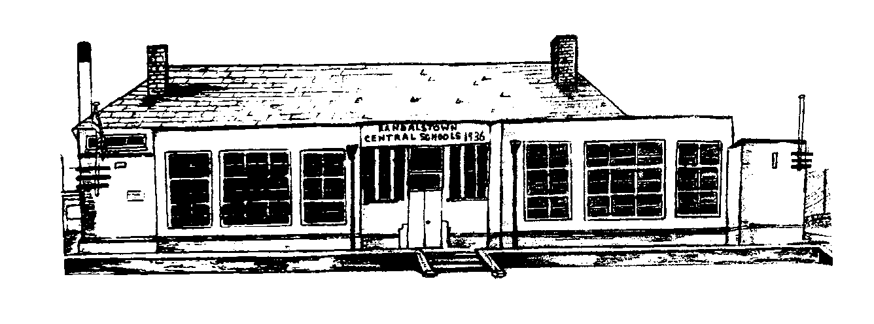

Randalstown Central
Primary School
To Be Reviewed

2023

Adopted

February 2022

Relationships & Sex
Education Policy (RSE)

Policy Basis
This Policy was drawn up in line with…
- DE Circular 2013/16
- DE Guidence 2015/22
Aims:
We hope to provide high quality RSE learning for our pupils. This teaching is underpinned by some key agreed aims.

- To ensure that the school meets its responsibility to provide a high quality RSE curriculum for all its pupils.
- To help pupils feel at ease with themselves and empower them to form and maintain healthy relationship with others.
- To help pupils to understand their individual needs and to respect the needs/wants of others.
- To promote an appreciation of the value of human life and the wonder of birth.
- To help pupils come to value family life and to appreciate the responsibilities of parenthood.
- To support both boys and girls to embrace puberty and seek pastoral support if required. This includes embracing ‘Period Dignity’
- To enable pupils to challenge inappropriate and unwanted attention from others.
- To empower pupils to protect themselves against dangers associated with the use of the internet and other multimedia.
- To assist/enable pupils’ families who find it challenging to discuss growing up and sexual development with their children.
- To increase pupils’ capacity to make informed choice guided by their values and beliefs.
- To empower pupils to identify prejudice and to respect the views, emotions and feelings of others.
- To help pupils understand and resist potential pressures from media or/and peers to conform to unhelpful/unrealistic images or/and behaviours.
- To develop in our pupils the self-esteem and skills to become confident adolescents.

Methodology
RSE is a lifelong process. It involves the acquisition of knowledge, understanding and skills. It also includes the development of attitudes, beliefs and values about personal and social relationships and gender issues.
The learning process begins informally with our parents long before any formal education takes place at school.
Sexuality includes all aspects of the human person that relate to being male or female and is subject to change and development throughout life. Sexuality is an integral part of the human personality and has biological, cultural, psychological, social and spiritual dimensions. It especially concerns the capacity to give and receive love; procreation and, in a more general way, the aptitude for forming relationships with others. It is a complex dimension of human life and relationships.
The RSE curriculum and other related disciplines will contribute toward enabling pupils to develop the skills necessary to form and maintain relationships and to make informed choices and decisions regarding health and wellbeing. Pupils should also be helped to develop skills to critically evaluate the wide range of information, opinions, attitudes and values.
Pupils need opportunities to develop:
- Practical skills for everyday living; for supporting others; for future parenting.
- Communication skills, learning to listen, listening to others’ points of view; putting one’s own view forward clearly and appropriately; giving and receiving feedback; handling and resolving conflict peacefully; being assertive.
- Decision-making and problem-solving skills for sensible choices made in the light of relevant information; making moral judgments about what to do in actual situations and putting these judgments into practice; acting responsibly and with initiative as an individual or as a member of a variety of groups;
- Inter-personal skills for managing relationships confidently and effectively; for developing as an effective group member or leader.
A Partnership across Home, School and Community
The effectiveness of this RSE Policy is dependent on a collaborative process involving teachers, parents, governors and other educational and health professionals. Each of the partners has distinctive contributions to make. Teachers, governors and parents can raise any concerns they might have about RSE issues and the Senior Leadership will address these or refer to the Board of Governors if necessary.
The Role of the Senior Leadership Team
A planned, structured and coherent approach to RSE will be sought throughout the school. Consultation will need to be initiated with governors, staff, parents, health professionals and other relevant community representatives as necessary.
The Role of the Governors
The Governors will try to foster and support the development of our RSE Policy and similar related policies by collaborating with teachers and parents. They shall facilitate the consultative process whereby the school community can respond and contribute on relevant issues. The Governors of the school will seek to accommodate and be sensitive to the religious and cultural beliefs of both teachers and parents while fulfilling their responsibility to ensure the availability of adequate RSE for all children.
The Role of Teachers
The classroom teacher has a significant and diverse role to play in the planning and implementation of RSE in the school. At all times the role must be considered to be complementary to that of parents, taking into consideration the individual needs, age, maturity, stage of development and family background of the child. The class teacher will strive to promote the aims of this policy and other related policies and deliver the requirements of RSE at the level appropriate to their particular class.
Involving Parents
Our aim is to develop a structure which enables both parents and teachers to work together. The home exerts a major influence on all aspects of a child’s life, and especially so in the domain of relationships and sexuality. Parents are often concerned about the information their children are receiving from their peers and from television, videos, newspapers and magazines. We will attempt to provide opportunities for pupils to consider this information and ensure they receive accurate information. Where puberty-related changes are being covered with Primary 6 and 7 classes, parents are informed about when these talks will take place, the content to be covered and the activities that pupils will undertake.
Curriculum Organisation
The primary curriculum offers opportunities to develop RSE in a holistic and cross-curricular way. Issues can be integrated within specific topics, discussed in subject-related contexts, addressed through health education, pastoral work and at assembly time as well as during visits from the school nurse or other agency.
In many instances, RSE shares content with TWAU, Science, Religious Education, Physical Education and English, as well as PDMU. Circle Time may be used as an appropriate tool to engage children in RSE.

Promoting cross-curricular skills

RSE is a rich and varied area of study. It lends itself very naturally to the teaching of literacy and the promotion of communication. The use of drama to explore issues, a wide variety of relevant texts to read and natural opportunities for pupils to express their ideas through writing.

Using Mathematics has also many applications in our teaching of RSE. For example, data handling can be used in the teaching of many contemporary issues related to RSE. This could include looking at trends and opinions e.g. perceptions of gender in media. It could also be used for pupils creating graphs or charts related to key issues. All aspects of mathematics can be explored via RSE it requires teachers to be creative and systematic.

The use of I.C.T. is a very powerful motivational and learning tool. Word processing, the constructing of graphs, animation and the creation of multimedia are all very useful in the teaching of RSE.

Teachers are asked to see the potential of RSE to teach the cross-curricular skills. They are asked to audit their teaching strategies to make sure that are varied and creative.

Promoting Thinking Skills and Personal Capabilities

At the core of our vision for RSE is that we are aiming to provoke pupils to think critically and apply this to real life situations. Our methodology also aims to promote collegial learning. The teaching of Thinking Skills and Personal Capabilities is both very natural and advantageous to the goals of the RSE.

Promoting cross-curricular Links

Teachers are encouraged to seek opportunities to link their teaching of RSE into their class topics. Like all areas of the pupils’ learning it makes sense to give it greater context by grounding it in a wider context.

Continuity and Progression
The RSE Scheme is developed to ensure that over a seven-year primary career every pupil will encounter a wide range of knowledge and develop many skills. We use a spiral model of progression that brings pupils back to previously encountered materials at a higher level of complexity. We are convinced that this allows all pupils’ needs to be covered, such as the physical changes related to puberty to be introduced.

Equality of Opportunity

All pupils whatever their gender, race, religion and social background must have equal access to quality RSE teaching.

We will endeavour to take account of the wishes of any parent who wishes their child to be excused from particular classes, such as the Puberty Talk in Primary 6 or 7. Any issues raised regarding the content of an element of RSE or other related Schemes will be addressed and resolved in a positive manner as part of the consultation process. Although full consultation may have been undertaken, a parent may still request that their child is excused from participating in some or all of the RSE lessons. In this circumstance, we will discuss the nature of the parent’s concerns, attempt to deal with any misunderstandings, identify the specific issues and lessons which are problematic and explain the implications for the pupil in terms of the parts of the statutory Schemes of study which will be missed. The social and emotional effects of exclusion should be considered as well as the likelihood that pupils will discuss the content of RSE.
RSE and Special Educational Needs.

Teachers have a responsibility to cater for the needs of all their pupils. It is important that all barriers are acknowledged and the teacher makes reasonable efforts to meet the needs of all pupils. Group tasks, open-ended tasks and differentiated materials should allow all children to participate fully.

Health and Safety

There are no specific health and safety issues related to RSE. Teachers, however, should be mindful that good practice is in place in all lessons to ensure an orderly, well-structured and safe learning environment.

Assessment & Reporting

Pupils’ attainment within RSE will be assessed via a range of methods. These include:

- Observing pupils’ responses.
- The quality of pupils’ engagement in class and group tasks.
- Pupils’ written tasks, artwork and other tangible outcomes.

As part of each pupil’s annual report they will receive a written comment relating to P.D.M.U.

Period Dignity
The school is taking part in the Period Dignity programme. Miss McCurdy is responsible for the programme and working with the senior girls to promote Period Dignity.

Review cycle of policy

The RSE Policy and Scheme will be reviewed and if required updated every year. This process will involve a staff and governor consultation.

Staff will be issued with a hard copy of the new policy after its approval.

A full version will be available to parents on the school website or the school office for reference

APPENDIX 1: USEFUL LOCAL ADDRESSES
- Childcare Northern Ireland, 11 University Street, Belfast, BT7 1FY. Tel: (028) 9065 2713.
- NSPCC, Jennymount Court, North Derby Street, Belfast, BT15 3HN. Tel: (028) 9035 1135.
APPENDIX 2: USEFUL NATIONAL ADDRESSES
- Childline UK, Freepost 1111, London, N1 OBR. Tel: (0800) 1111. A free national helpline for children with any problems.
- Kidscape, 2 Grosvenor Gardens, London, SW1W ODH. Tel: (020) 7730 3300.

