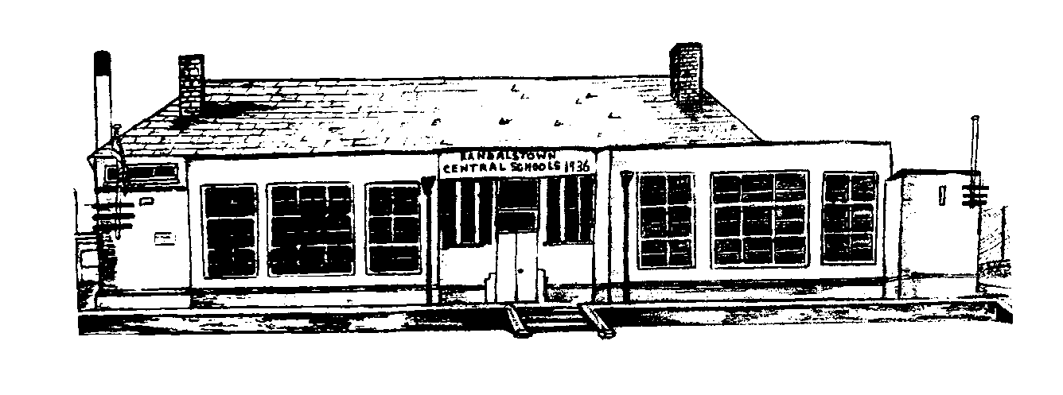

To Be Reviewed
2022

Adopted
October 2021

Social Media Policy

Randalstown Central
Primary School

Context

Mission Statement
As a school we wish to uphold a positive image with all stakeholders; pupils, staff, parents, governors and community members. (For the purposes of this policy, the aforementioned individuals will be referred to collectively as ‘school community members’) We strive at all times to create an environment where there is mutual respect, where each person is valued as an individual and pastoral care is an integral part of education.

Use of ICT allows all pupils to gain confidence and ability in an ever-changing society and prepares them for the challenge of a rapidly developing and evolving technological world...
- To provide opportunities to enable all our staff, pupils and parents to be confident, competent and independent users of ICT.
- To provide an environment where access to ICT resources is natural and commonplace.
- To ensure ICT has a fundamental role in developing and enhancing our school’s key learning aims in promoting the pupils’ educational, physical and social needs.
- ICT encourages our staff and pupils to work collaboratively.

Social Networking
Social networking is everywhere. It is common to find parents, children, co-workers and others on such sites.
Examples of these sites include, Facebook, Twitter, LinkedIn, YouTube, MySpace, etc. With social networks, people across the world have access to tools and options that were previously non-existent. However, there are now just as many new opportunities to connect as there are to get into potential danger. One thing we often forget while having fun on social networks is that almost anybody can see what we are doing. While we are tagging photos of our friends or are posting comments to them, it can be easy to forget that someone else who has been invited onto a social networking site can also view them. Often there is a minimal amount of control over who ultimately gets to see our post.

Once something appears on the Internet, it's almost impossible to remove. As these sites continue to grow in popularity, so too does the value of the information on them to parties other than those directly involved. Social networking users need to take a step back and think about just what they are posting onto the Internet as it can have serious ramifications.

This policy serves to convey the guidelines which members of our school community in Randalstown should operate within. We recognise that as a school we hold no jurisdiction in policing social media platforms, but urge the whole school community to work collaboratively to communicate appropriately.

As educators, we believe that the partnership of parent and school is intrinsic to realising the best educational outcomes for our pupils. This policy outlines the context of social media and the responsibilities that staff and parents have in role-modelling effective and safe communication on social media. (Appendix 2)

Responsibilities of Staff
People who work with children and young people should always maintain appropriate professional boundaries, avoid improper contact or relationships and respect their position of trust.

With regard to relationships, individuals who work with children and young people should not attempt to establish a relationship, which might include:

- communication of a personal nature
- inappropriate dialogue through the internet
- sharing of personal contact details including email address, online identity or phone numbers

Individuals, who work with children and young people, should be extremely careful in corresponding with people on social networking sites. Staff relationships with children and young people should, at all times, remain professional and they should not correspond with children and young people through such sites or add them as 'friends'.

It is worth bearing in mind that, on such sites, an inappropriate or even misconstrued communication may have the potential to impact upon their careers, or even result in criminal investigation.

In addition staff should bear in mind who may access their own profiles on such websites. Staff should therefore take care as to the information they display about themselves, their personal lives and should not make any reference to school or individuals within it. They should not disclose on their online profile, ‘where they work’ ,
and at no time should they post anything which is capable of bringing the school into disrepute.

They should also ensure that they have installed, and are using, the highest level of privacy settings.

Individuals who work with children and young people and others, with whom they may be in a position of trust, should exercise caution when using social networking sites and avoid inappropriate communication of any kind.

Staff should not post any images of employees, children, governors or anyone directly connected with the school whilst engaged in school activities without checking parental permission has been given or gaining prior permission from the Principal. Before posting any images of school community members taken at events not related to school, for example at social events, permission should be directly sought from the parties involved.

Responsibilities of Parents/Guardians
Parents and Guardians will be made aware of their responsibilities regarding their use of social networking by the school, by receiving a copy of this policy.

Methods of school communication include ParentMail, the Website & Facebook page, newsletters, letters and verbal discussion.

Pictures taken of pupils within the school setting/at school events should not be posted on social networking sites without parents’ permission. Before posting any images of school community members, taken at events, not related to school, for example at social events, permission should be directly sought from the parties involved.

Furthermore, parents should report any incidents of cyber bullying (and/or bullying) as soon as they are discovered.

Complaints made in public through social media are detrimental and could be damaging to the school community and as such are not beneficial to the children. Parents/carers should bear this in mind before publishing such complaints online. Any complaints, should they arise, should be pursued through the appropriate channels by making contact with the member of staff involved, the Vice Principal or the Principal. A meeting can then be arranged at a mutually convenient time to bring about a resolution to the issue.

Parents/ carers should also be aware that defamatory comments made on-line may well be unlawful and may result in legal action.

Guidance/Protection for Pupils and Staff on using Social Networking
Any breaches of this policy will be fully investigated. Where it is found that there has been a breach of policy this may result in action being taken under the EA Disciplinary Procedures. A breach of this policy will be considered to be a serious disciplinary offence which is also contrary to the school’s ethos and principles.

No pupil under 13 should be accessing social networking sites . This is the guidance from both Facebook and MSN.

There is a mechanism on Facebook where pupils can be reported via the Help screen.
http://www.facebook.com/help (Appendix 1)

The Board of Governors will take appropriate action in order to protect the school’s reputation and that of its staff, parents, Governors, children and anyone else directly linked with Randalstown Central Primary School.

Appendices
Appendix 1

Underage Pupils Using Facebook

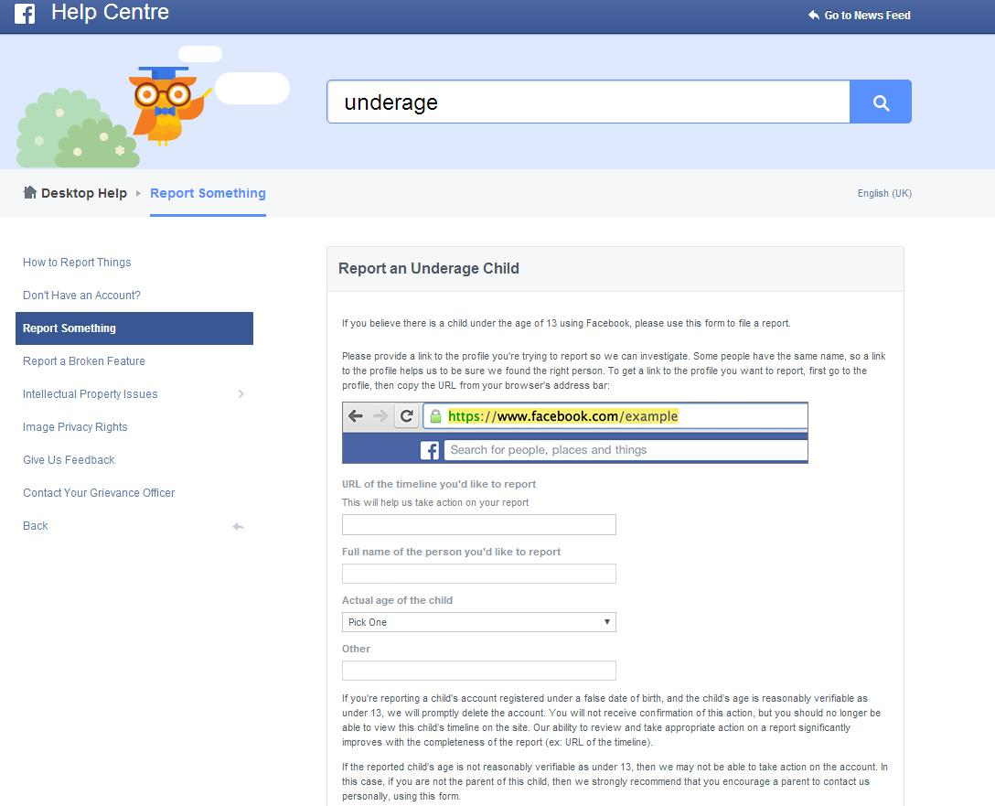

Appendix 2
Advice from Department of Education & Other Sources

Appendix 2

General advice to everyone:
- Don’t share personal information or images with people you don’t know.
- Don’t accept friend requests with someone you don’t know – not everyone online may be who they say they are.
- Set privacy settings on all devices so that only people you know can view your account.
- Don’t post anything online that you are not happy to be shared, particularly inappropriate images or videos. It may seem like a bit of fun with friends at the time but there is always a chance those images could be shared or get into the wrong hands and could lead to harmful situations such as stalking, abuse or blackmail.
- If someone has made you feel uncomfortable or you have had disturbing interaction online, tell police or a trusted adult. You can ring the police on 101 or for help and advice ring Childline on 0800 1111.
- The internet can be a great place but it is important to remember there are people out there who may wish to abuse, exploit, intimidate or bully you online – if this happens to you, tell someone immediately.
- Remember that if things do go wrong online, there are people who can help.
- If you receive any inappropriate images or links, it is important that you do not forward it to anyone else. Contact police or tell a trusted adult immediately. By doing this you could help prevent further such incidents. You will not get into trouble.

General advice to parents:
- The most important thing is to have conversations with your children - talk to them about the benefits and dangers of the internet so that you can empower them to use the internet safely.
- Cultivate an interest in their online activities - their favourite websites, online games and interests and keep an eye on what they are doing online.
- Don't be afraid to ask your children who they are talking to online and what they are talking about and remind them how important it is to tell a trusted adult if something happens online that makes them feel uncomfortable or worried because there are people who can help.
- Become a ‘net-savvy’ parent - the best safeguard against online dangers is being informed. Jump in and learn the basics of the Internet - read articles, take a class, and talk to other parents. You don’t have to be an expert to have a handle on your child’s online world.
- Go to www.getsafeonline.org for lots of useful advice and information on how to stay safe online. safeguardingni.org will also provide information for parents and carers on e-safety.

