Emotional Health &
Wellbeing Policy

Randalstown Central
Primary School
To Be Reviewed
2023
Adopted
January 2022
Emotional Health & Wellbeing Policy
This policy is based on the joint publication “Children & Young People’s EMOTIONAL HEALTH AND WELLBEING in Education Framework” (DENI & DoHNI February 2021)
Mission
In Randalstown Central Primary School, we strive to be a Mentally Healthy School. Where we provide a whole‑school approach to mental health and wellbeing, helping children to flourish, learn and succeed by providing opportunities for them, and the adults around them, to develop the strengths and coping skills that underpin resilience. We consider positive mental health and wellbeing as fundamental to our values and culture, where child, staff and parent wellbeing is seen as “everybody’s business”.
Aims of Policy
To help…
- The Children to build resilience and to manage their own emotional health & wellbeing.
- Identify and address wellbeing needs and issues when they arise.
- Establish a framework/model to provide early support to children’s wellbeing needs
- Minimise the number of children who require specialist help, later in life.

Definition of Mental Health.
In Randalstown Central PS we accept the definition of Mental Health as agreed by the World Health Organisation and amended by the European Ombudspersons (ENOC) Annual Conference (2018).

“A state of wellbeing that allows children to develop and become aware of their own unique personality, to build their own identity, to fulfil their own potential, to cope with the challenges of growing up; to feel loved, secure and accepted as unique individuals and to be able to be happy, play, learn and to participate and contribute to family and community”

Points of Reference

- Emotional Health & Wellbeing. This refers to being able to cope during the continuum of life’s experiences, from…

- When we feel healthy, happy and life is going well, to
- When things aren’t going so well but we are still able to cope with the ups and downs of life.

- Mental Health generally includes…

- Emotional Wellbeing
- Psychological Wellbeing
- Social Wellbeing

- Mental Health & Physical Health
In this school, children will be encouraged to view Mental Health in the same way as they do with Physical Health. Aspects of their life that they can and need to ‘look after’, so that they can try to prevent illness.

Emotional Wellbeing.
In this school, we agree that children can develop their own Social and Emotional skill sets, and we acknowledge the five key aspects of Social and Emotional Capability, as set out by the Early Intervention Foundation (2015)

Self Perceptions /
Self Awareness

Motivation

Social
Motivation

Wellbeing

Resilience &
Coping
Self Control /
Self Regulation

Key Aspects of Social & Emotional Wellbeing
Self-Perceptions / Self-Awareness | - sense of self direction and self esteem  - the belief that one’s own actions can make a difference
Motivation | - contributes positively to significant life outcomes. For example achievement, performance and wellbeing (Reeve, 2018)  - motivation is visible through gestures and facial expressions, intense effort, immediacy
Self-Control /  Self-Regulation | - learning about your own feelings and emotions, understanding how and why they happen, recognising them (and those of others), and developing effective ways of managing them  - greater impulse control
Social | - relationship skills  - communication skills  - peer relationships
Resilience & Coping | - strongly influenced by the people and the conditions that surround us  - a focus on wellbeing with a hopeful mindset / resilience lens, can help us mitigate future risks and allow young people to cope when they encounter the inevitable challenges as they progress through life

Model of Support
The model of support used in this school, encourages wellbeing for all, along with early & specialised intervention when required.

- Promotion of Emotional Health
- Prevention of Emotional Harm &
- Early Intervention to support to re-establishment of Wellbeing.

Support
Model

Wellbeing
For All

Enhanced
Support

Early
Support

WELLBEING FOR ALL –
A Whole Child, Whole School, Whole Community Approach
Wellbeing For All

Whole Child | - Adopting a holistic, integrated approach.  - Recognising that a child or young person entering school feeling happy, healthy, safe and connected to school is more likely to fully engage in learning.  - Identifying those children who may not be feeling this way and ensuring that additional support is provided to address their individual needs.  - Encourage, support and challenge (where appropriate) to better prepare children for further education, work and adult life.  - Recognising that all behaviour is communication – not just “acting out” or being aggressive, but also silent and withdrawn behaviours that can also present in a distressed or worried child or young  person.  - Create opportunities to hear the voice of the child.
Whole School | - A trauma informed compassionate approach.  - Leadership prioritises a culture and ethos that promotes a sense of caring, belonging and respect for all and plans strategically to improve emotional health and wellbeing for all.  - Providing an emotionally secure and safe environment and spaces.  - Recognising parents and carers as being integral to the school and the child’s wellbeing.  - Recognising that teacher-pupil and pupil-pupil relationships are crucial for wellbeing.
Whole Community | - Recognising the school is a key hub within our community.  - Linking with local voluntary and community services including sports clubs, churches and local businesses.
Staff Wellbeing | - Ethos and environment of the school places a high value and significance on staff wellbeing.  - An understanding that if staff are not effectively supported they cannot be expected to properly support the children in their care.  - A culture of trust where all staff feel valued and know how to access support if needed, for example through the use of staff debriefing/supervision.  - Supporting and providing comprehensive and on-going training as deemed necessary.  - Support given to the emotional health & wellbeing of educational setting leaders by the employing authority.
Parents & Carers | - Encourage and promote the involvement of parents to contribute to the life of the School  - Creating a better sense of connectedness between parents and the school, and fostering mutual respect.  - Recognising that for some parents and carers, engaging with staff can be challenging, for example those who themselves have had a difficult relationship during their own time at school.  - Encouraging parental and carer engagement through a welcoming open door policy, invitations to attend informal events (class breakfast / celebrating achievement etc) helping to build up trust and mutual understanding.  - Empowering parents to promote emotional wellbeing within the home environment, reinforcing the wellbeing culture and ethos of the school.  - Recognising that when parents are involved in an intervention there is a higher degree of success.

Effective Practice Within the School…
- Commitment to whole school wellbeing from the Principal & Staff

- Promoting a caring, supportive culture and ethos embedded throughout the whole school community involving children, staff, parents and carers.

- Promoting a sense of belonging and respect for all, and providing an emotionally secure and safe environment that encourages and instils a sense of self-esteem, self‑regulation, skill development and overall resilience.

- Integrating emotional health and wellbeing into practice, and throughout the curriculum.

- Ensuring the culture and ethos impacts on the teacher‑pupil relationship, the culture within individual classrooms and classroom management strategies.

- Giving children a voice - ensuring they have the opportunity to contribute to decisions that may impact on emotional wellbeing.

- Reviewing pastoral structures regularly to identify and meet children’s need.

- Delivering programmes, such as Neuronimo, to promote resilience and wellbeing.

EARLY SUPPORT -
Early Identification of difficulties and early intervention to address them
“Early intervention means identifying and providing effective early support to children and young people who are at risk of poor outcomes. Effective early intervention works to prevent problems occurring, or to tackle them head-on when they do, before problems get worse. It also helps to foster a whole set of personal strengths and skills that prepare a child for adult life. Early intervention can take different forms, from home visiting programmes to support vulnerable parents, to schoolbased programmes to improve children’s social and emotional skills, to mentoring schemes for young people who are vulnerable to involvement in crime.” (Early Intervention Foundation)
Effective Practice Within The School…
- Identifying children who are showing early signs of problems with their emotional wellbeing and working with them and their parents or carers to provide the support they need.

- Intervening early to provide support before difficulties escalate, supporting the individual and also benefitting society as a whole by reducing the impact of mental health problems.

- Delivering a school based programme to support and improve children and young people’s emotional wellbeing.

- Working collaboratively with Education Authority, Health, Social Services and RISE and as required with wider family support services.

ENHANCED SUPPORT
Enhanced support is for when there is a need for more specialist service intervention for children and young people presenting with more complex needs which schools cannot be expected to provide.

Effective Practice Within The School…
- Working collaboratively with EA Education, Health, Voluntary and Community services to help deliver a seamless model to support children and their families when there is evidence of need. Such as Social Services and RISE

- Maintaining a continuum of care and connectedness with the school/setting, even if the child is unable to attend

- Working in partnership with EA to ensure support is provided for the wellbeing of staff, as well as to develop and deliver whole school programmes and initiatives, such as Neuronimo

Support From The Education Authority

Behaviour
Support
Special
Education
Education
Welfare
LAC
Support
EA
Wellbeing
Support
Staff Health
& Wellbeing

Child
Protection
Service
Educational
Psychology
School
Development
Critical
Incident
Support

Support From Community Agencies

CAMHS
Support

Community
Wellbeing
Support
School
Nursing
Support

RISE
Support

Social
Services
Support

School Emotional Health & Wellbeing Actions & Programmes.
What we already do…
Within the school, the supportive ethos provides a safe environment, within which, we can support Wellbeing. (See Pastoral Care Policy)

Specifically, the Practice within the school can be seen to support Wellbeing in all we do, including…
- Skill Development Group Work and Investigations
- Self Regulation Peer Mediation
- Self Esteem Sports Clubs, Drama Performances, Music etc
- Having a Voice ECO & School Council

Within the Classrooms and Curriculum Wellbeing is supported by…
- Circle-time
- PDMU

We engage the support and partnership of Parents through…
- Seeking their views on policies etc
- An active PTA
- Regular Consultations and Reports

We maintain our links with external providers through regular contact with
- EA
- Social Services
- Educational Psychology

Emotional Health & Wellbeing Programmes In School.
Specific Programmes
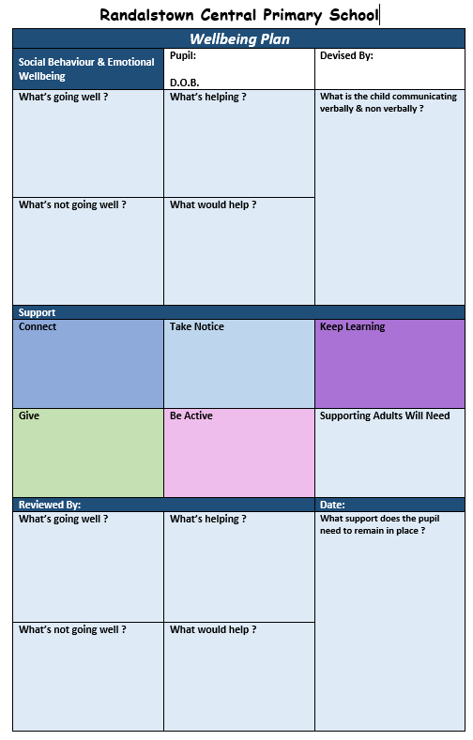
For pupils who are presenting with pronounced Wellbeing issues and require ‘enhanced support’, a ‘Social Behaviour Emotional Wellbeing Plan’ will be put in place.

Whole School Programmes
We are introducing a number of whole school programmes to encourage and develop Wellbeing For All and as part of our ‘early support’
Take Five
This programme is a more general approach based on the same 5 steps of Wellbeing used in the ‘Wellbeing Plan’ above. This encourages the pupils to…
- Be Active Keeping fit makes us feel good.
- Connect With friends and family…as that makes us feel loved.
- Give Something nice to a friend or family member, even a
smile…as that makes us feel happy.
- Take Notice Of the world around you…and how you feel.
- Keep Learning Learning new things makes us feel proud.
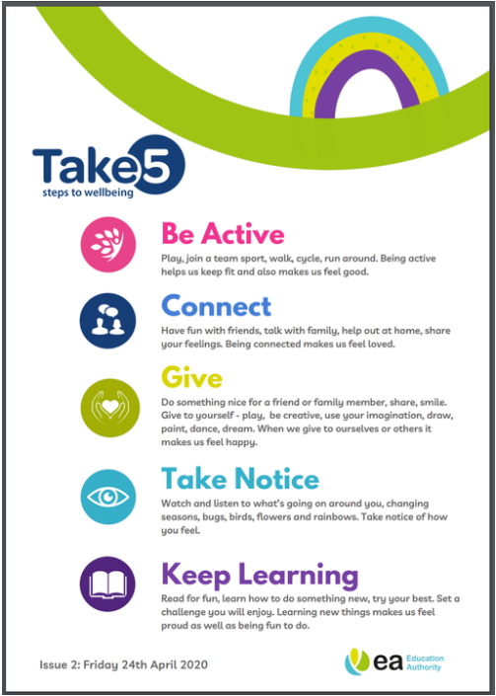

Bucket Fillers & Bucket Dippers
This is a program, aimed at helping pupils to understand the benefits of positive attitudes and behaviour.
Bucket Filling refers to kind actions and behaviour practised by students. It relies on the analogy that every person carries with them an invisible bucket.
This bucket contains a person's feelings and emotions.
When the bucket is full, this represents us feeling happy and contented.
However, when it is empty, we feel low, upset and dissatisfied.
Bucket-fillers are those who act in a way that fills another person's bucket and refers to those who practise kindness and good behaviour. For example…
- Being kind to everyone you meet
- Helping those who are struggling
- Paying someone a compliment
- Being respectful
- Showing someone you care for them
Bucket Dippers are the opposite. They refers to actions or behaviour that have a negative effect on those around us. It can include things like
- Making fun of someone
- Saying unkind things
- Refusing to help someone else
- Bullying someone
- Being disrespectful
When pupils understand their actions can have an effect on their Wellbeing, they can learn that if they are feeling low or upset they can ‘do’ something about it, to improve their Wellbeing.

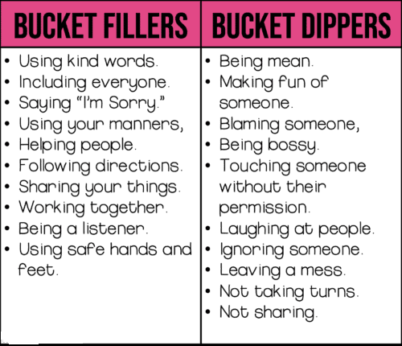

Neuronimo
The aim of the initiative is to promote mental wellness in our children.
(From EA Website)
Created by the Reverse The Trend Foundation, the ‘Neuronimo’ programme uses neuroscience to tackle Wellness. The evidence base for this programme is supported by research undertaken by Ulster University and the University of Southampton.
“During the pandemic there has been an increase in mental health issues among children and difficulties have been heightened as restrictions have persisted. There is substantial evidence that good mental health and wellbeing are critical precursors to learning,” said Reverse The Trend Foundation Chief Executive Cait Hall.
“The Neuronimo programme offers children an understanding of their mental health, helping them to connect the dots between mind and body. When young people understand why they feel a certain way - why their mind goes blank, why they can’t sleep or get a tummy pain before an event - they can do something about it.
“The Neuronimo programme equips young people with the knowledge and the skills to manage both mental and physical health."
Neuronimo has already been rolled out in Great Britain where 75,000 children have benefitted from the programme.
“Schools consistently highlight mental and physical health as key issues for our children and young people,” said Nicola Topping, Head of Pupil Wellbeing Services with the Education Authority.
“We also know however that school staff have many demands on their time. The Neuronimo programme is flexible and many of the mental health tasks can be completed in under five minutes.
“These tasks develop important life skills that support pupils’ ability to cope with and negotiate their way through difficult situations, build positive relationships and help prevent mental health difficulties from developing.”
Information on how schools can sign up for Neuronimo can be found at
www.reversethetrend.org.uk
or watch this short video for further information, https://bit.ly/3ia2rjt.

